Integration test

1. **Method to test**

Top Down

1. **Pre-requisites for Integration test**

Pass unit test

1. **Test cases :**

**URS-1 user can register account normal flow**

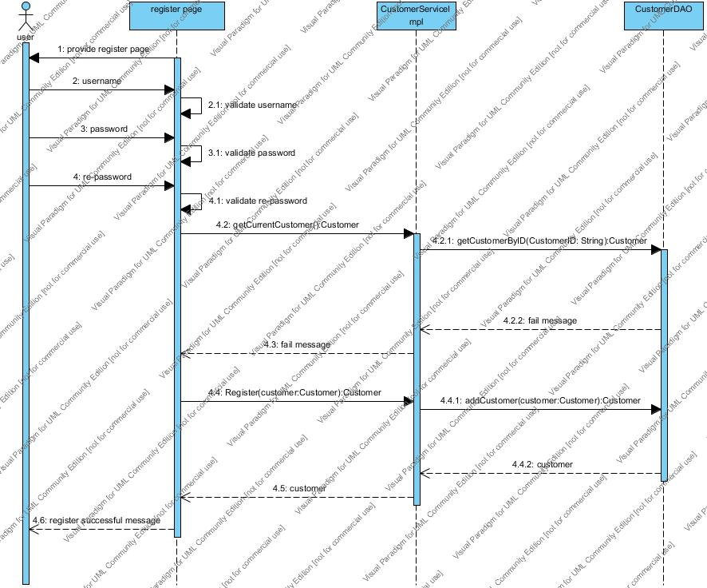

**ITC-01**

Check the integration between register page and CustomerServiceImpl by getCurrentCustomer():Customer method

|  |  |
| --- | --- |
| **Test Case ID** | ITC-01 |
| **Test Item(s)** | register page →CustomerServiceImpl |
| **Input Specification** | valid but not existed customer password and username that user input |
| **Expect Output** | return null |
| **Actual Output** |  |

Check the integration CustomerServiceImpl and CustomerDAO by Customer getCustomerById(String customerID) method

**ITC-02**

|  |  |
| --- | --- |
| **Test Case ID** | ITC-02 |
| **Test Item(s)** | CustomerServiceImpl →CustomerDAO |
| **Input Specification** | validate but not existed customer password and username that user input |
| **Expect Output** | Return null |
| **Actual Output** |  |

Check the integration between register page and CustomerServiceImpl by Customer Register(Customer customer) method

**ITC-03**

|  |  |
| --- | --- |
| **Test Case ID** | ITC-03 |
| **Test Item(s)** | register page →CustomerServiceImpl |
| **Input Specification** | Validate and existed customer password and username that user input |
| **Expect Output** | Return the customer object |
| **Actual Output** |  |

Check the integration CustomerServiceImpl and CustomerDAO by Customer addCustomer(Customer customer) method

**ITC-04**

|  |  |
| --- | --- |
| **Test Case ID** | ITC-04 |
| **Test Item(s)** | CustomerServiceImpl →CustomerDAO |
| **Input Specification** | validate and existed customer password and username that user input |
| **Expect Output** | Return the customer object |
| **Actual Output** |  |

**Input Data:**

|  |  |
| --- | --- |
| **Username:** | 552115511@vr.camt.info |
| **Password:** | 552115511 |

**URS-1 user can register account alternative flow B**

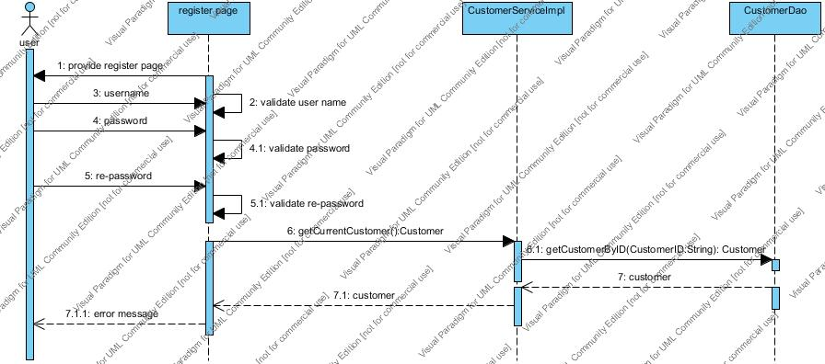

**ITC-05**

Check the integration between register page and CustomerServiceImpl by getCurrentCustomer():Customer method

|  |  |
| --- | --- |
| **Test Case ID** | ITC-05 |
| **Test Item(s)** | register page →CustomerServiceImpl |
| **Input Specification** | valid customer password and username that user input |
| **Expect Output** | return a customer if the customer exist in database |
| **Actual Output** |  |

**ITC-06**

Check the integration CustomerServiceImpl and CustomerDAO by Customer getCustomerById(String customerID) method

|  |  |
| --- | --- |
| **Test Case ID** | ITC-06 |
| **Test Item(s)** | CustomerServiceImpl →CustomerDAO |
| **Input Specification** | validate customer password and username that user input |
| **Expect Output** | return a customer if the customer exist in database |
| **Actual Output** |  |

**Input Data:**

|  |  |
| --- | --- |
| **Username:** | [542115511@vr.camt.info](mailto:552115511@vr.camt.info?subject=) |
| **Password:** | 542115511 |

**URS-2 User can update his/her own account normal flow**

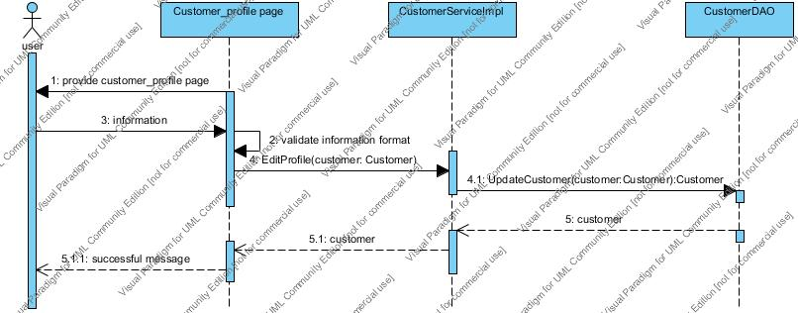

**ITC-07**

Check the integration between Customer_profile page and CustomerServiceImpl by Customer updateCustomer(Customer customer) method

|  |  |
| --- | --- |
| **Test Case ID** | ITC-07 |
| **Test Item(s)** | customer_profile page →CustomerServiceImpl |
| **Input Specification** | valid customer password and optional address, picture that user input |
| **Expect Output** | return a customer object |
| **Actual Output** |  |

**ITC-08**

Check the integration CustomerServiceImpl and CustomerDAO by Customer getCustomerById(String customerID) method

|  |  |
| --- | --- |
| **Test Case ID** | ITC-08 |
| **Test Item(s)** | CustomerServiceImpl →CustomerDAO |
| **Input Specification** | validate customer password and username that user input |
| **Expect Output** | return a customer object |
| **Actual Output** |  |

**Input Data:**

|  |  |
| --- | --- |
| **Password:** | 542115510 |
| **Address:** | chiangmai, thailand |

**URS-3 User can login account normal flow**

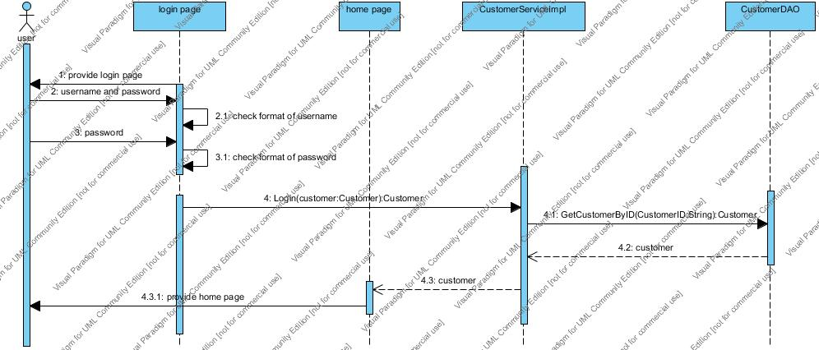

**ITC-09**

Check the integration between login page and CustomerServiceImpl by Customer Login(Customer customer) method

|  |  |
| --- | --- |
| **Test Case ID** | ITC-09 |
| **Test Item(s)** | login page →CustomerServiceImpl |
| **Input Specification** | valid and matched customer password and optional address, picture that user input |
| **Expect Output** | return a customer object |
| **Actual Output** |  |

**ITC-10**

Check the integration CustomerServiceImpl and CustomerDAO by Customer getCustomerById(String customerID) method

|  |  |
| --- | --- |
| **Test Case ID** | ITC-10 |
| **Test Item(s)** | CustomerServiceImpl →CustomerDAO |
| **Input Specification** | validate and matched customer password and username that user input |
| **Expect Output** | return a customer object |
| **Actual Output** |  |

**Input Data:**

|  |  |
| --- | --- |
| **Username:** | [542115511@vr.camt.info](mailto:552115511@vr.camt.info?subject=) |
| **Password:** | 542115511 |

**URS-3 User can login account alternative flow A**

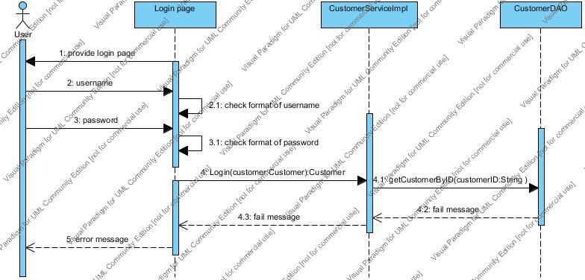

**ITC-11**

Check the integration between login page and CustomerServiceImpl by Customer Login(Customer customer) method

|  |  |
| --- | --- |
| **Test Case ID** | ITC-11 |
| **Test Item(s)** | login page →CustomerServiceImpl |
| **Input Specification** | valid and unmatched customer password and optional address, picture that user input |
| **Expect Output** | return null |
| **Actual Output** |  |

**ITC-12**

Check the integration CustomerServiceImpl and CustomerDAO by Customer getCustomerById(String customerID) method

|  |  |
| --- | --- |
| **Test Case ID** | ITC-12 |
| **Test Item(s)** | CustomerServiceImpl →CustomerDAO |
| **Input Specification** | validate and unmatched customer password and username that user input |
| **Expect Output** | return null |
| **Actual Output** |  |

**Input Data:**

|  |  |
| --- | --- |
| **Username:** | [542115511@vr.camt.info](mailto:552115511@vr.camt.info?subject=) |
| **Password:** | 542115508 |

**URS-5 User can search product he/she want normal flow**

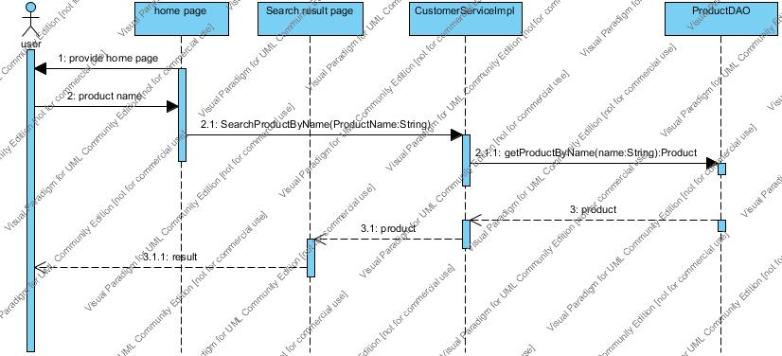

**ITC-13**

Check the integration between home page and CustomerServiceImpl by List<Product> SearchProductByName(String productName) method

|  |  |
| --- | --- |
| **Test Case ID** | ITC-13 |
| **Test Item(s)** | home page →CustomerServiceImpl |
| **Input Specification** | existed product name |
| **Expect Output** | return product list |
| **Actual Output** |  |

**ITC-14**

Check the integration CustomerServiceImpl and ProductDAO by Product getProductByName(String productName) method

|  |  |
| --- | --- |
| **Test Case ID** | ITC-14 |
| **Test Item(s)** | CustomerServiceImpl →ProductDAO |
| **Input Specification** | existed product name |
| **Expect Output** | return product list |
| **Actual Output** |  |

**Input Data:**

|  |  |
| --- | --- |
| **Product name:** | iPhone 4s |

**URS-5 User can search product he/she want alternative flow A**

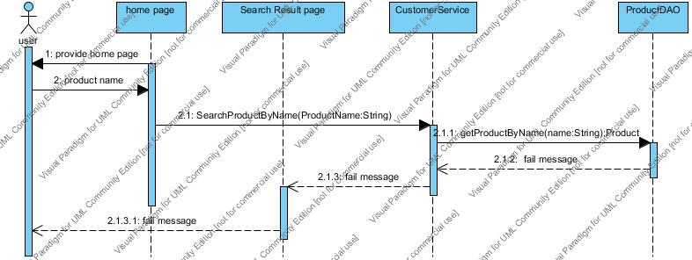

**ITC-15**

Check the integration between home page and CustomerServiceImpl by List<Product> SearchProductByName(String productName) method

|  |  |
| --- | --- |
| **Test Case ID** | ITC-15 |
| **Test Item(s)** | home page →CustomerServiceImpl |
| **Input Specification** | not existed product name |
| **Expect Output** | return null |
| **Actual Output** |  |

**ITC-16**

Check the integration CustomerServiceImpl and CustomerDAO by Product getProductByName(String productName) method

|  |  |
| --- | --- |
| **Test Case ID** | ITC-16 |
| **Test Item(s)** | CustomerServiceImpl →ProductDAO |
| **Input Specification** | not existed product name |
| **Expect Output** | return null |
| **Actual Output** |  |

**Input Data:**

|  |  |
| --- | --- |
| **Product name:** | a |

**URS-6 User can select product he/she wants to buy normal flow**

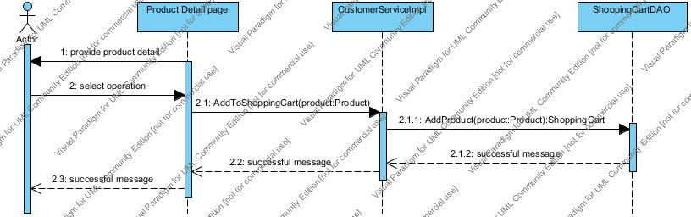

**ITC-17**

Check the integration between Product Detail page and CustomerServiceImpl by void AddToShoppingCart(Product product) method

|  |  |
| --- | --- |
| **Test Case ID** | ITC-17 |
| **Test Item(s)** | Product Detail page →CustomerServiceImpl |
| **Input Specification** | product which user choose |
| **Expect Output** | none |
| **Actual Output** |  |

**ITC-18**

Check the integration CustomerServiceImpl and ShoppingCartDAO by void AddToShoppingCart(Product product) method

|  |  |
| --- | --- |
| **Test Case ID** | ITC-18 |
| **Test Item(s)** | CustomerServiceImpl →ShoppingCartDAO |
| **Input Specification** | product which user choose |
| **Expect Output** | None |
| **Actual Output** |  |

**URS-7 User can save shipping cart normal flow**

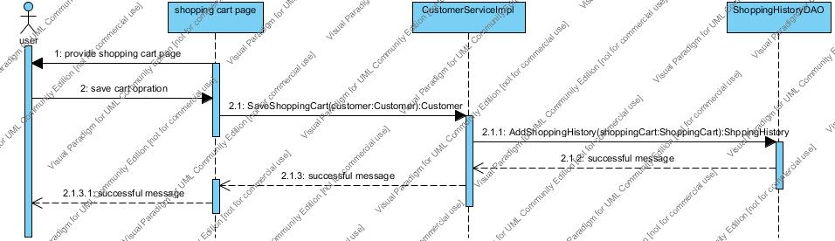

**ITC-19**

Check the integration between Shopping Cart page and CustomerServiceImpl by Customer SaveShoppingCart(Customer customer) method

|  |  |
| --- | --- |
| **Test Case ID** | ITC-19 |
| **Test Item(s)** | Shopping Cart page →CustomerServiceImpl |
| **Input Specification** | current customer |
| **Expect Output** | the customer object |
| **Actual Output** |  |

**ITC-20**

Check the integration CustomerServiceImpl and ShoppingHistoryDAO by ShoppingHistory AddShoppingHistory(ShoppingCart shoppingCart) method

|  |  |
| --- | --- |
| **Test Case ID** | ITC-20 |
| **Test Item(s)** | CustomerServiceImpl →ShoppingHistoryDAO |
| **Input Specification** | shopping cart customer chooses to save |
| **Expect Output** | shopping history object |
| **Actual Output** |  |

**URS-9 User can view the shopping history normal flow**

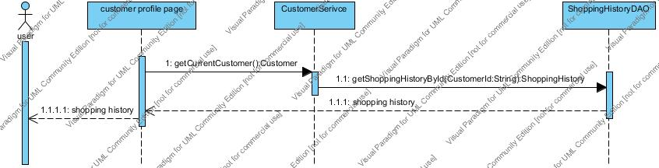

**ITC-21**

Check the integration between customer profile page and CustomerServiceImpl by Customer getCurrentCustomer() method

|  |  |
| --- | --- |
| **Test Case ID** | ITC-21 |
| **Test Item(s)** | customer profile page →CustomerServiceImpl |
| **Input Specification** | none |
| **Expect Output** | the customer object |
| **Actual Output** |  |

**ITC-22**

Check the integration CustomerServiceImpl and ShoppingHistoryDAO by ShoppingHistory getShoppingHistoryById(String customerID) method

|  |  |
| --- | --- |
| **Test Case ID** | ITC-22 |
| **Test Item(s)** | CustomerServiceImpl →ShoppingHistoryDAO |
| **Input Specification** | customer id of current customer |
| **Expect Output** | shopping history object |
| **Actual Output** |  |

**URS-9 User can view the shopping history alternative flow A**

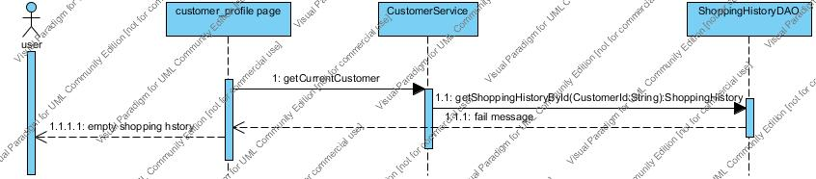

**ITC-23**

Check the integration between customer profile page and CustomerServiceImpl by Customer getCurrentCustomer() method

|  |  |
| --- | --- |
| **Test Case ID** | ITC-23 |
| **Test Item(s)** | customer profile page →CustomerServiceImpl |
| **Input Specification** | none |
| **Expect Output** | the customer object |
| **Actual Output** |  |

**ITC-24**

Check the integration CustomerServiceImpl and ShoppingHistoryDAO by ShoppingHistory getShoppingHistoryById(String customerID) method

|  |  |
| --- | --- |
| **Test Case ID** | ITC-24 |
| **Test Item(s)** | CustomerServiceImpl →ShoppingHistoryDAO |
| **Input Specification** | customer id of current customer |
| **Expect Output** | null |
| **Actual Output** |  |

**URS-10 Administrator can add product** **normal flow**

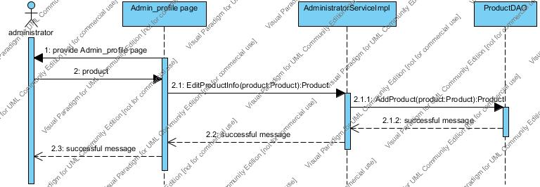

**ITC-25**

Check the integration between Admin_ profile page and AdministratorServiceImpl by Product EditProductInfo(Product product) method

|  |  |
| --- | --- |
| **Test Case ID** | ITC-25 |
| **Test Item(s)** | Admin_ profile page →AdministratorServiceImpl |
| **Input Specification** | valid product information |
| **Expect Output** | the product object |
| **Actual Output** |  |

**ITC-26**

Check the integration AdministratorServiceImpl and ProductDAO by Product addProduct(Product product) method

|  |  |
| --- | --- |
| **Test Case ID** | ITC-26 |
| **Test Item(s)** | AdministratorServiceImpl →ProductDAO |
| **Input Specification** | valid product |
| **Expect Output** | the product object |
| **Actual Output** |  |

**Input Data:**

|  |  |
| --- | --- |
| **Product ID:** | 123 |
| name | Ipod |
| Price | $123.4 |
| Description | One MP3 player produced by Apple product |

**URS-11 Administrator can view all the shopping histories normal flow**

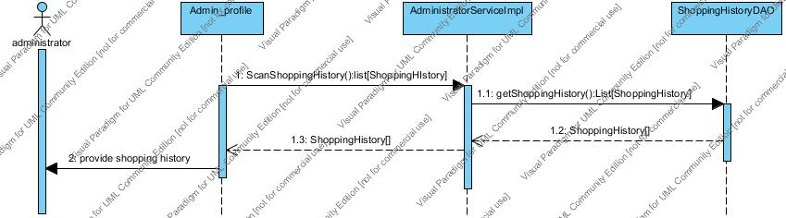

**ITC-27**

Check the integration between Admin_ profile page and AdministratorServiceImpl by List<ShoppingHistory> ScanShoppingHistory() method

|  |  |
| --- | --- |
| **Test Case ID** | ITC-27 |
| **Test Item(s)** | Admin_ profile page →AdministratorServiceImpl |
| **Input Specification** | None |
| **Expect Output** | the Shopping history list |
| **Actual Output** |  |

**ITC-28**

Check the integration AdministratorServiceImpl and ShoppingHistoryDAO by List<ShoppingHistory> getShoppingHistories() method

|  |  |
| --- | --- |
| **Test Case ID** | ITC-28 |
| **Test Item(s)** | AdministratorServiceImpl →ShoppingHistoryDAO |
| **Input Specification** | None |
| **Expect Output** | the Shopping history list |
| **Actual Output** |  |

**URS-11 Administrator can view all the shopping histories alternative flow A**

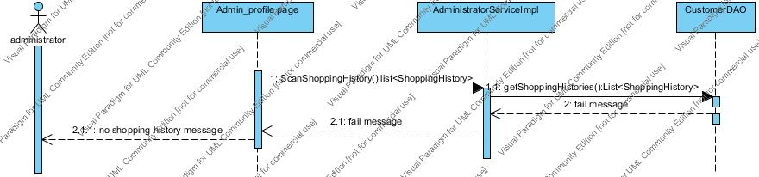

**ITC-29**

Check the integration between Admin_ profile page and AdministratorServiceImpl by List<ShoppingHistory> ScanShoppingHistory() method

|  |  |
| --- | --- |
| **Test Case ID** | ITC-29 |
| **Test Item(s)** | Admin_ profile page →AdministratorServiceImpl |
| **Input Specification** | None |
| **Expect Output** | Null |
| **Actual Output** |  |

**ITC-30**

Check the integration AdministratorServiceImpl and ShoppingHistoryDAO by List<ShoppingHistory> getShoppingHistories() method

|  |  |
| --- | --- |
| **Test Case ID** | ITC-30 |
| **Test Item(s)** | AdministratorServiceImpl →ShoppingHistoryDAO |
| **Input Specification** | None |
| **Expect Output** | Null |
| **Actual Output** |  |